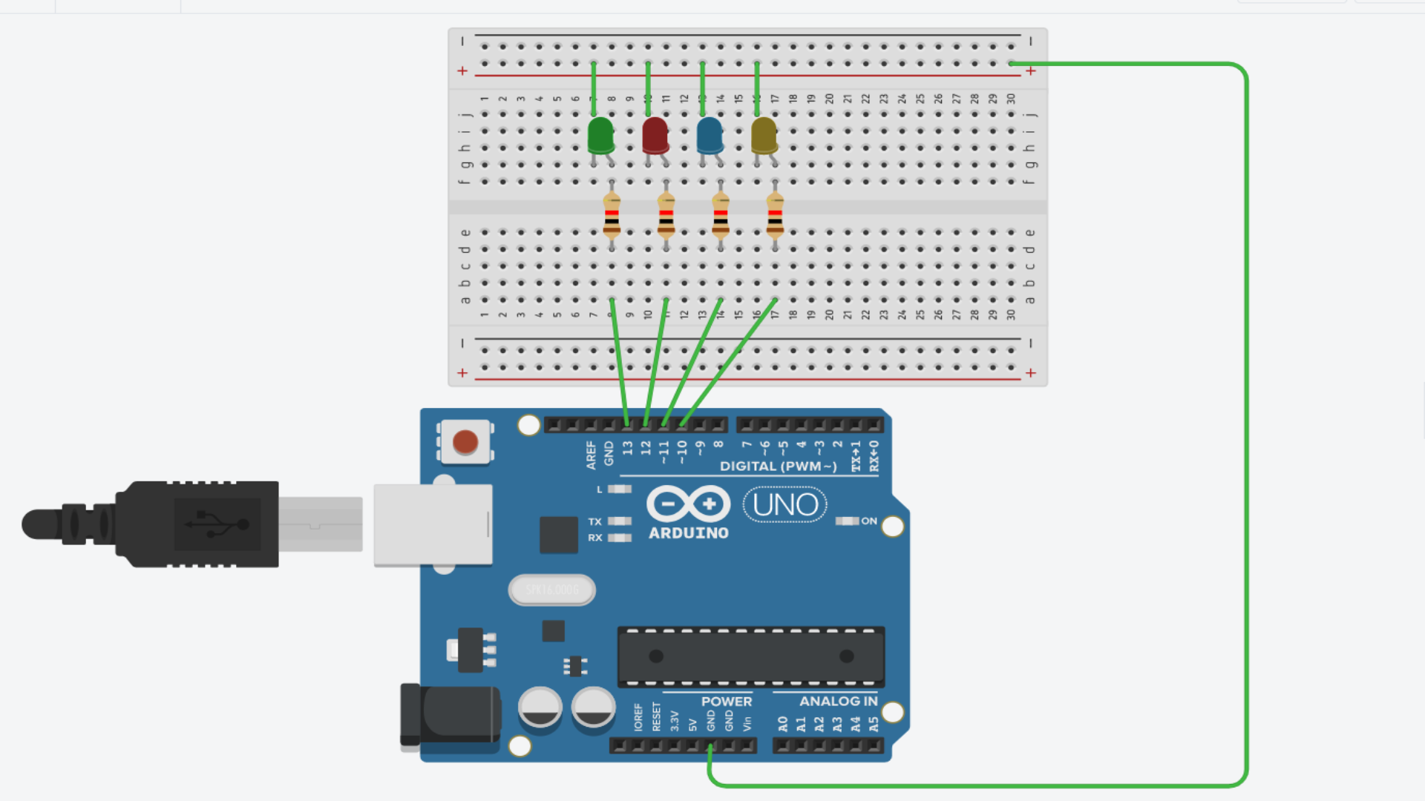

LED CHASER

***THEORY***

***CONCEPT USED***:

Ohm’s Law.

Basic knowledge of arduino and breadboard.

Knowledge of connecting wires to make a circuit.

***LEARNING AND OBSERVATION:***

Learning – learned to make connections of LED, breadboard and arduino .

Observations- working of arduino’s software and hardware.

***PROBLEM AND TROUBLESHOOTING:***

Problem in compiling the code and making the connections in breadboard.

The problem of coding can be solved by practicing more c and c++ language.

Selecting port of arduino causes problem sometimes.

***PRECAUTIONS:***

Use proper working LEDs.

Positive and negative should be connected correctly

Making the connections of breadboard with arduino carefully.

***LEARNING AND OUTCOMES:***

We learn to code and make circuit using arduino.